SE 4485: Software Engineering Projects

Fall 2026

Detailed Design Documentation

Group Number | 9
Project Title | Skills Catalog & Inventory (Team A)
Sponsoring Company | Sabre Corporation
Sponsor(s) | Jeff Buchmiller
Students | 1.Tobenna Nwosu  2. Jason Lehman  3. Alice Askerup  4. Russel Costales  5. Kim Chau  6. Jasmine Shrestha

Skills Catalog & Inventory

1. ABSTRACT
This is the Detailed Design Documentation for the Skills Catalog & Inventory project sponsored by Sabre Corporation. This project is one of the ten projects for this course SE 4485.001 at the University of Texas at Dallas. This document complies with the Software Engineering Standards set by the IEEE Standard for Software Project Management Plans (IEEE Std 1058-1998). The document sets the architectural design and structure for the project.

B. TABLE OF CONTENTS
1. Abstract 3
2. Table of Contents 4
3. List of Figures 5
4. List of Tables 5
1. Introduction 6
1.1 Introduction to the entire document 6
1.2 Purpose and scope of the document 6
1.3 Description of the structure of the document 6
2. GUI (Graphical User Interface) Design 7
3. Static Model: Class Diagram 13
3.1 Figure 7: Static Model 13
3.2 Tier Decomposition 13
3.3 Detailed Class Specifications by Tier 14
4. Dynamic Model: Sequence Diagrams 20
4.1 Figures 8–13: Dynamic Model 20
4.2 Dynamic Model Overview & Notation 26
4.3 Detailed Phase Decompositions 26
5. Rationale for Design Model 30
6. Traceability from Requirements to Detailed Design Model 30
7. Configuration Management 35
8. Engineering Standards and Multiple Constraints 36
9. Glossary 36
10. Additional References ……………………………………………………………………………………………36

C. LIST OF FIGURES
- Figure 1: Home Dashboard View
- Figure 2: Add New Skill Dialog View
- Figure 3: Organization Hierarchy and Member Skills View
- Figure 4: Skills Inventory and Certifications View
- Figure 5: Data Reports Dashboard View
- Figure 6: Skills Catalog View
- Figure 7: Static Model
- Figure 8: Dynamic Model (Phases 1 - 2)
- Figure 9: Dynamic Model (Phases 3 - 4)
- Figure 10: Dynamic Model (Phase 5)
- Figure 11: Dynamic Model (Phase 6)
- Figure 12: Dynamic Model (Phase 7)
- Figure 13: Dynamic Model (Phase 8)

D. LIST OF TABLES
- Project & Team Details
- General / Business Operations Functional Requirements Traceability
- Workforce Planner Functional Requirements Traceability
- Resource Manager Functional Requirements Traceability
- Organizational Leader Functional Requirements Traceability
- Configuration Management & Version History

1. INTRODUCTION

1.1 Introduction to the entire document
The Detailed Design Documentation describes the design details of the Skills Catalog & Inventory (Team A) project. This document provides an overview of the system’s architecture, structure, and the interactions between different components. This document serves as a guide for the team to develop the system by explaining how the system’s requirements will be translated into a detailed design that supports implementation.

1.2 Purpose and scope of the document
The purpose of this Detailed Design Document is to describe the system’s internal structure, user interface design, and interactions between components for the Skills Catalog and Inventory application. It translates the functional and non-functional requirements into a detailed technical design that will guide the implementation, testing, and integration of the system's components. This document will include class diagrams to visually represent the system's classes, attributes, methods, and relationships. The document will also include GUI diagrams to outline the layouts, navigation, and interactive elements of the user interface for each stakeholder role. Sequence diagrams will also be included to demonstrate the order of interaction between users, system components, and the database during key operations. This document and diagrams will serve as a technical reference for the development team to ensure that the system’s architecture and user experience align with the outlined functional and non-functional requirements

1.3 Description of the structure of the document
This Detailed Design Document bridges the gap between the requirements and how it is implemented. The document is organized into the following sections:
- Introduction: Introduces the document while explaining its purpose and scope.
- GUI (Graphical User Interface) Design: Presents the GUI design of the Skills Catalog and Inventory.
- Static Model: Presents the static model of the system using UML class diagrams to show the classes, their attributes and operations, and the relationship among them.
- Dynamic Model: Presents the dynamic model of the system using UML sequence diagrams to show how objects interact over time.
- Rationale for the detailed design model: Gives the rationale for detailed design model while explaining the design decisions, alternatives considered, and the patterns and principles applied.
- Traceability from requirements to detailed design model: Maps requirements in Requirements Documentation to design elements that satisfy it.
- Configuration management: Links to relevant repository management tools.
- Engineering Standards and Multiple Constraints: Lists the industry standards guiding the project.
- Glossary and Additional References: Defines key terms and provides supporting references.

2. GUI (Graphical User Interface) Design: Link to GUI Design in Figma

Figure 1: Home Dashboard View
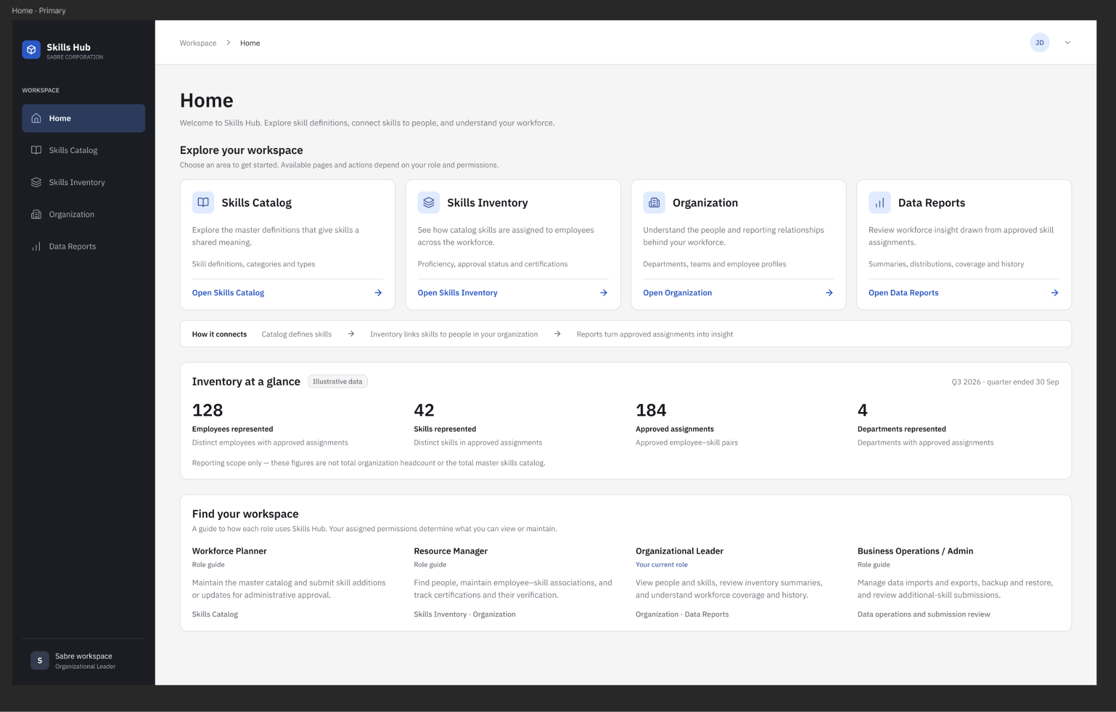

Figure 2: Add New Skill Dialog View
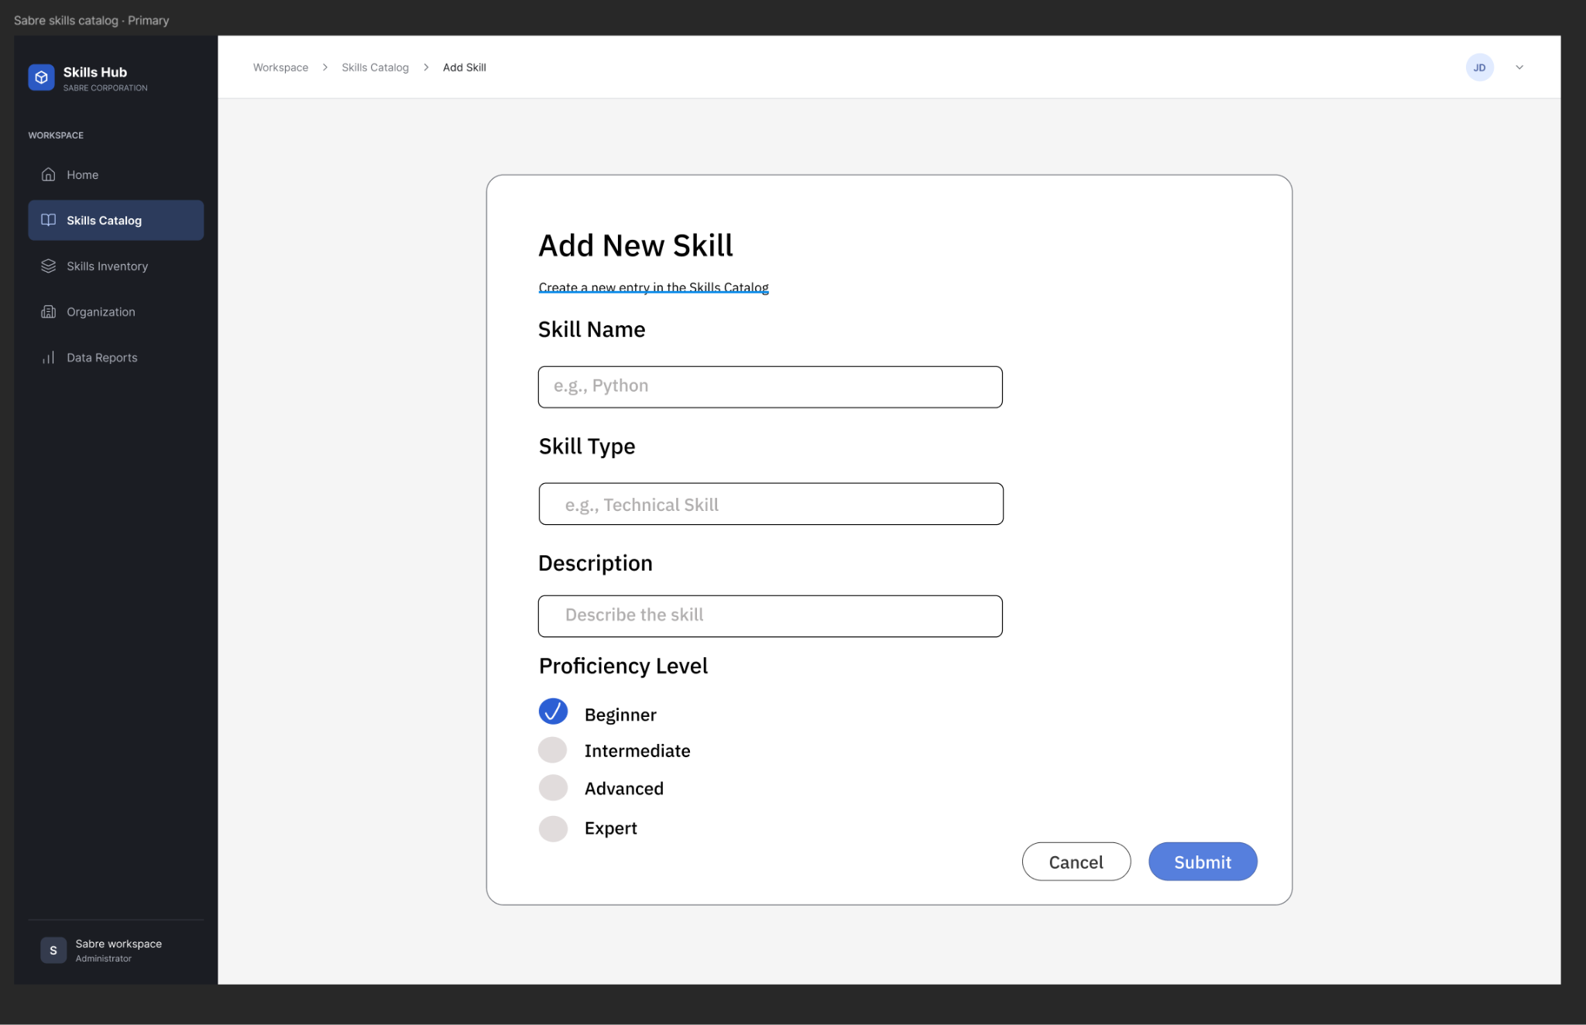

Figure 3: Organization Hierarchy and Member Skills View
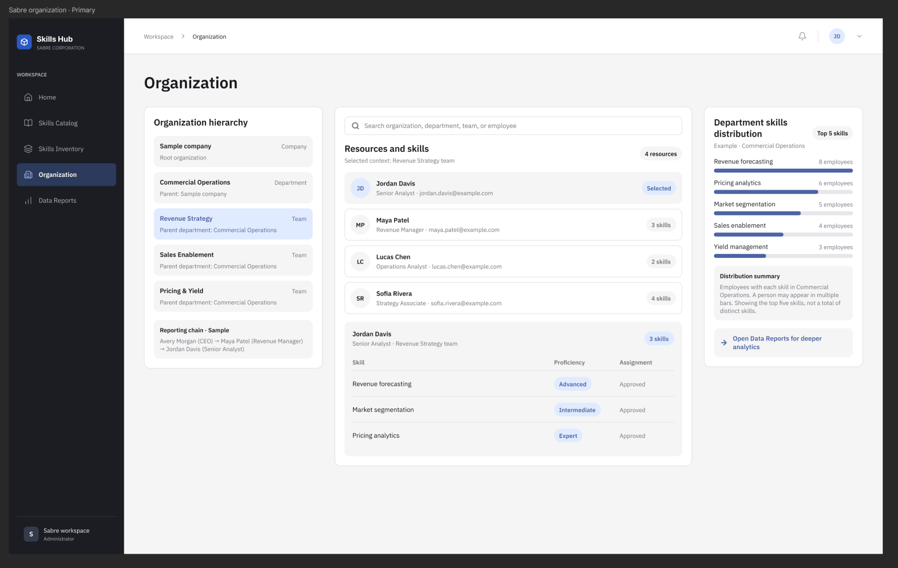

Figure 4: Skills Inventory and Certifications View
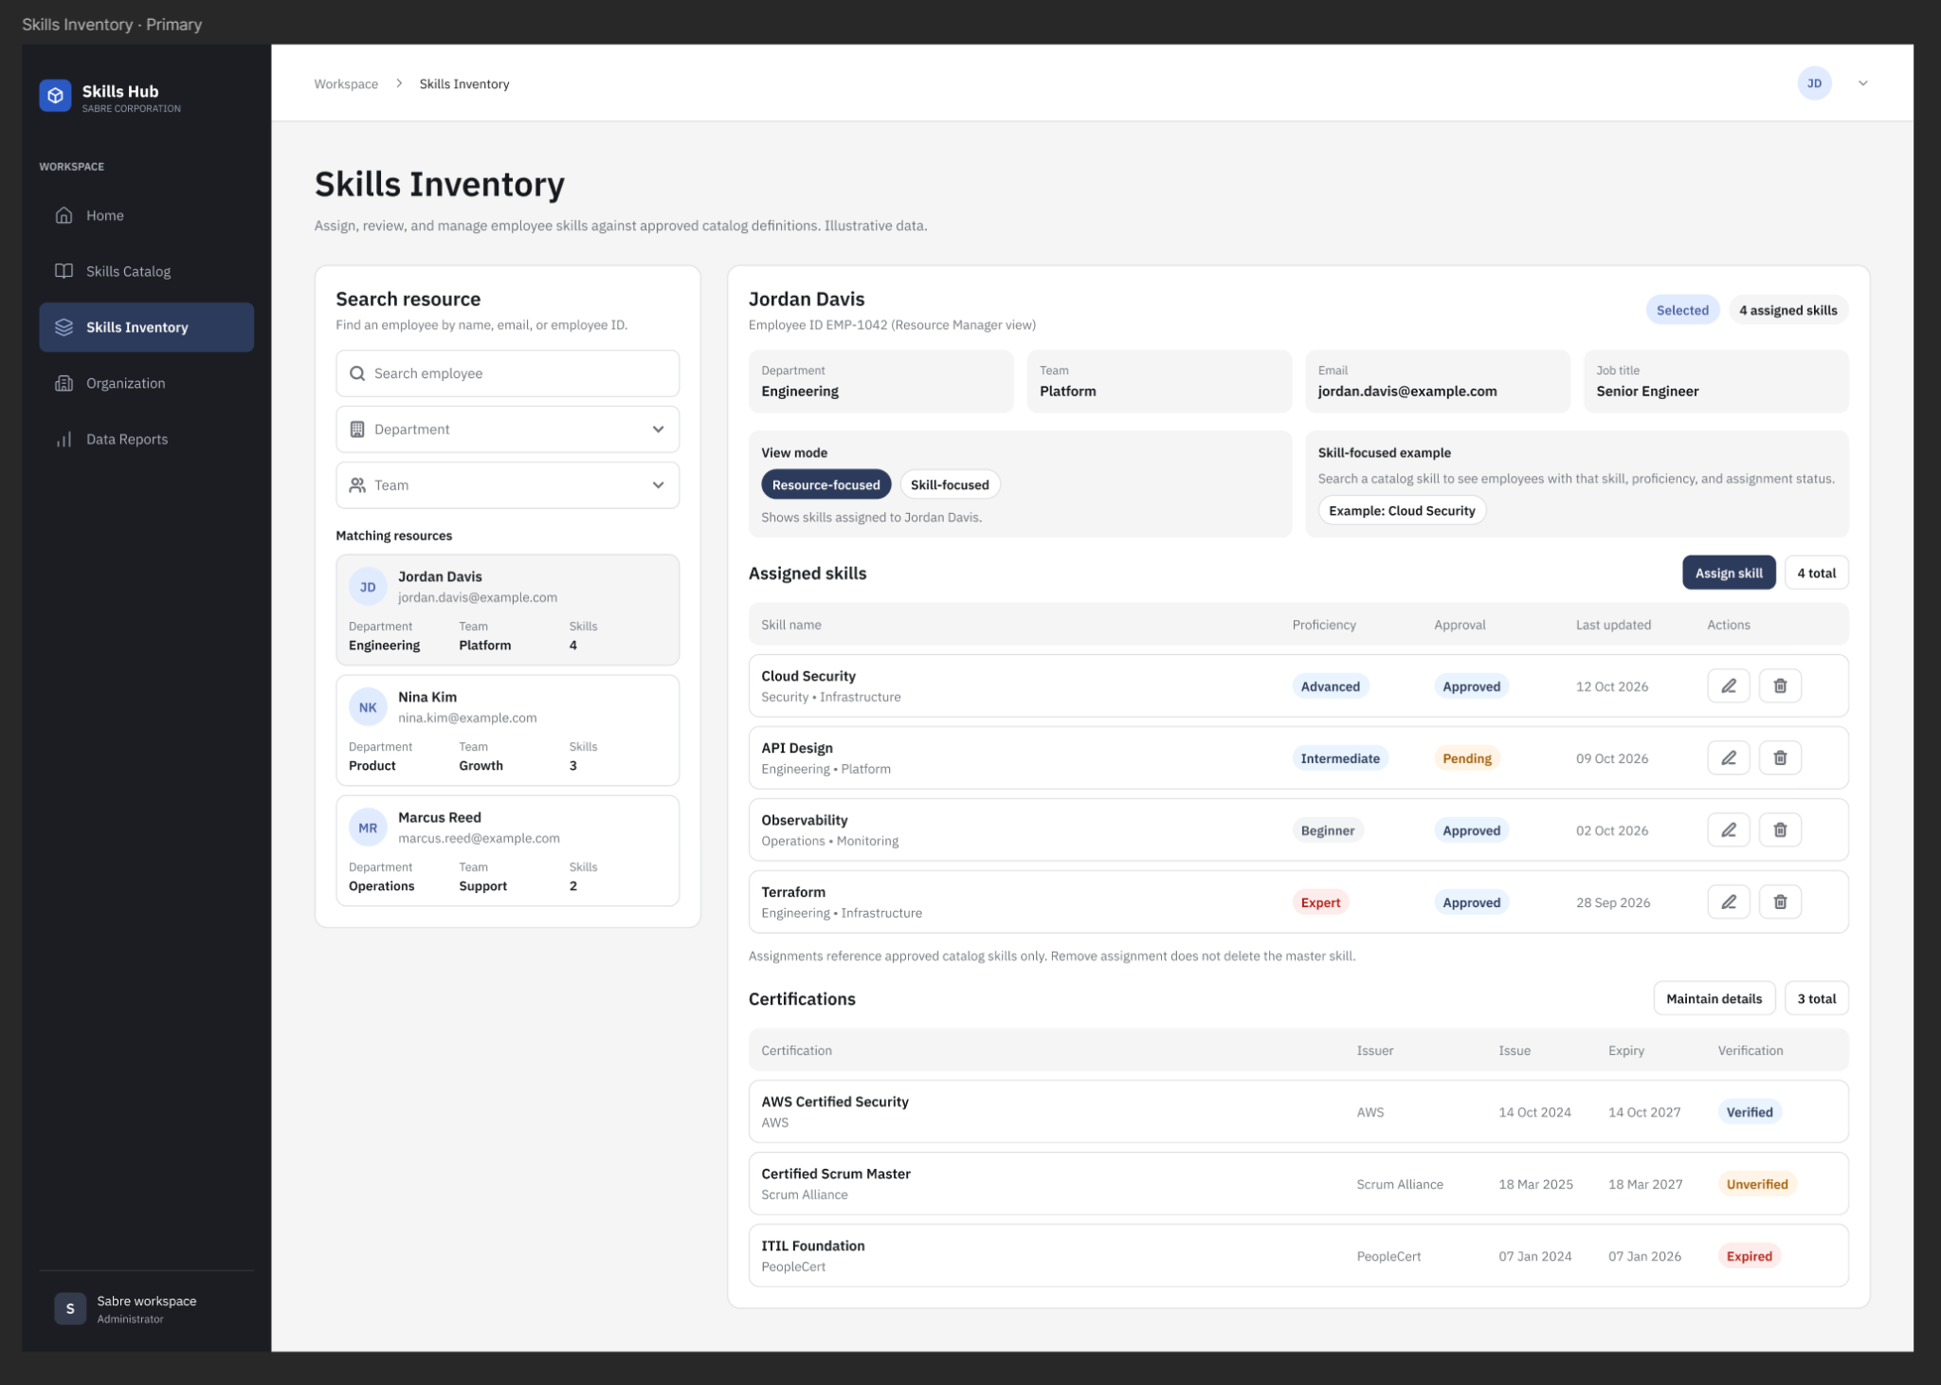

Figure 5: Data Reports Dashboard View
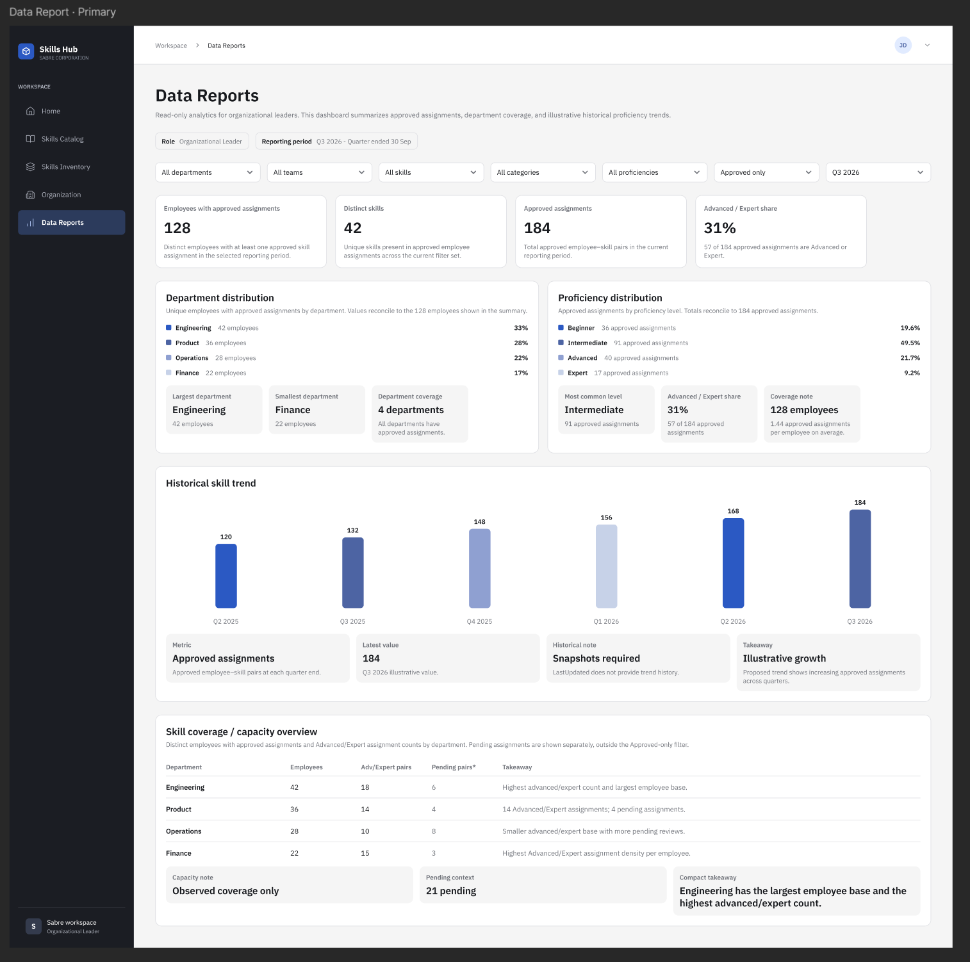

Figure 6: Skills Catalog View
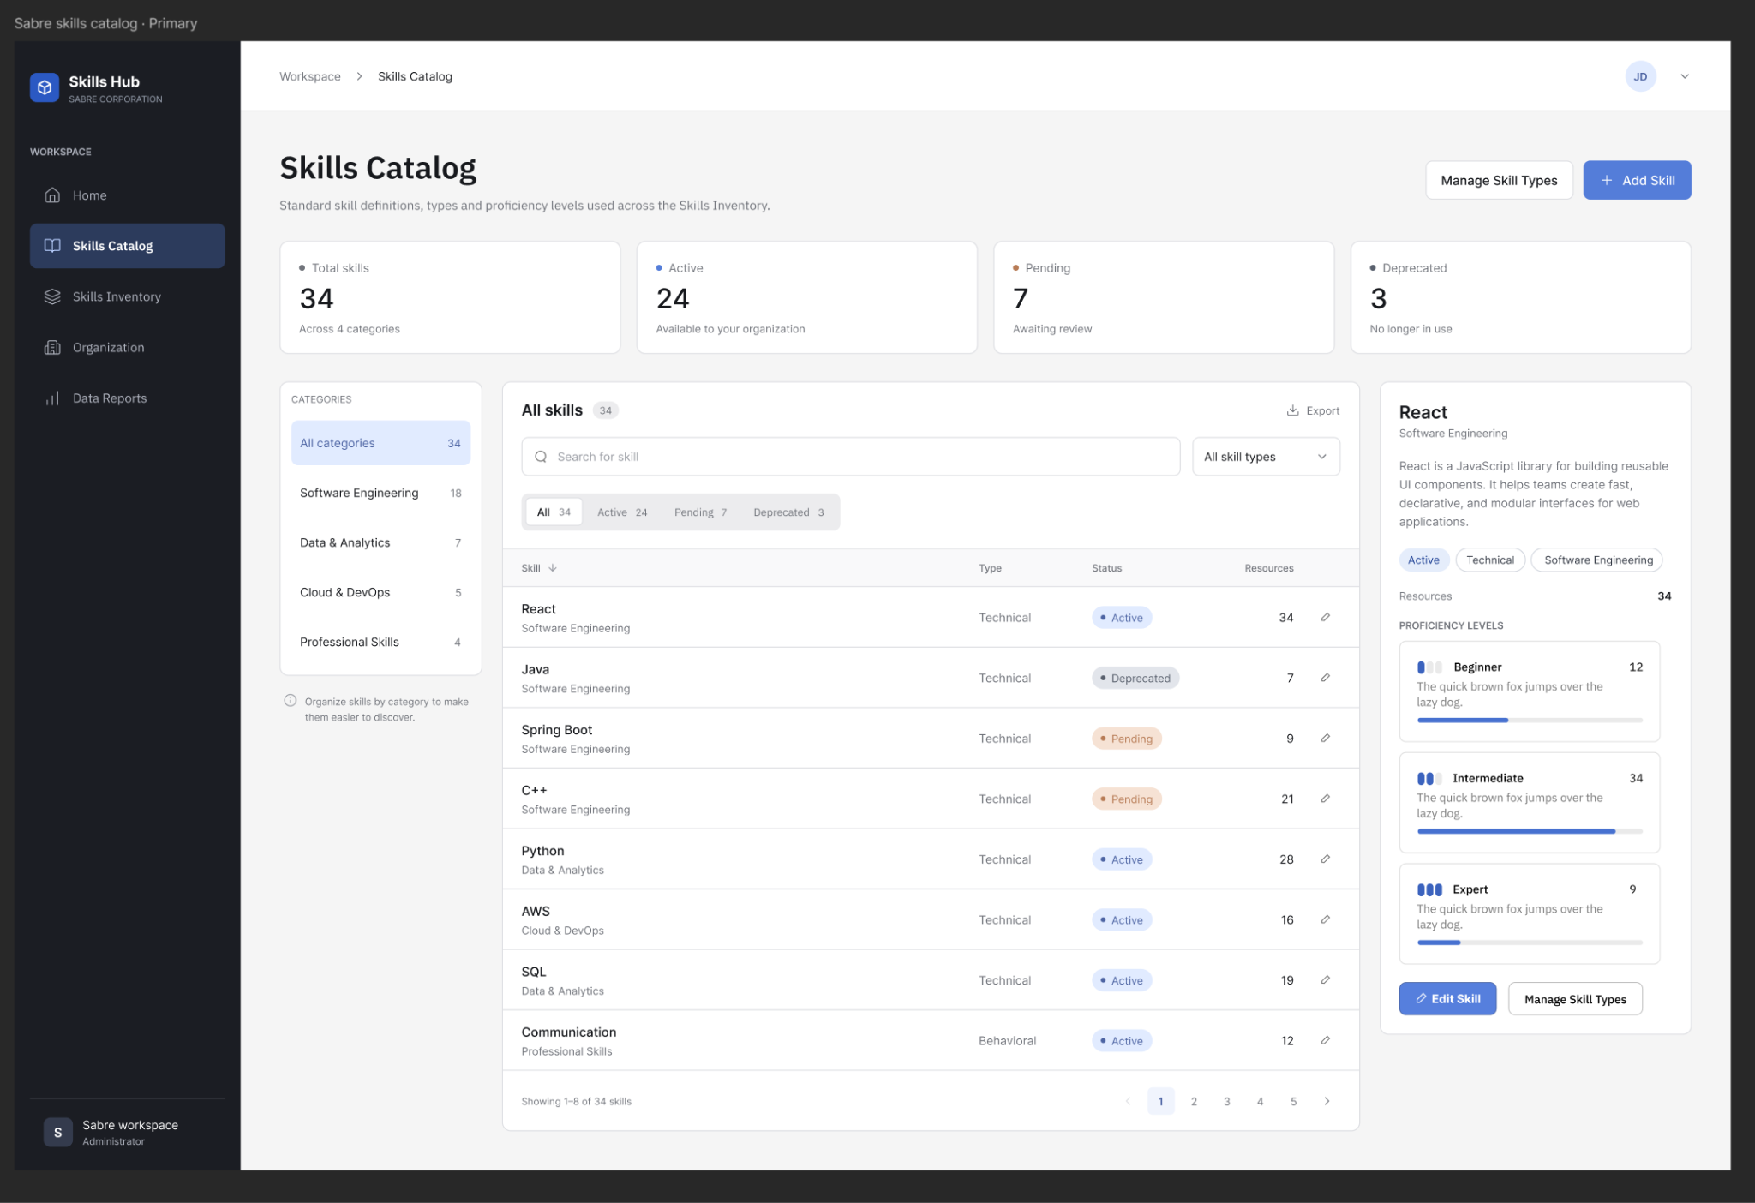

3. Static Model: CLASS DIAGRAM (Captured in draw.io) → Link to Model

3.1 Figure 7: Static Model
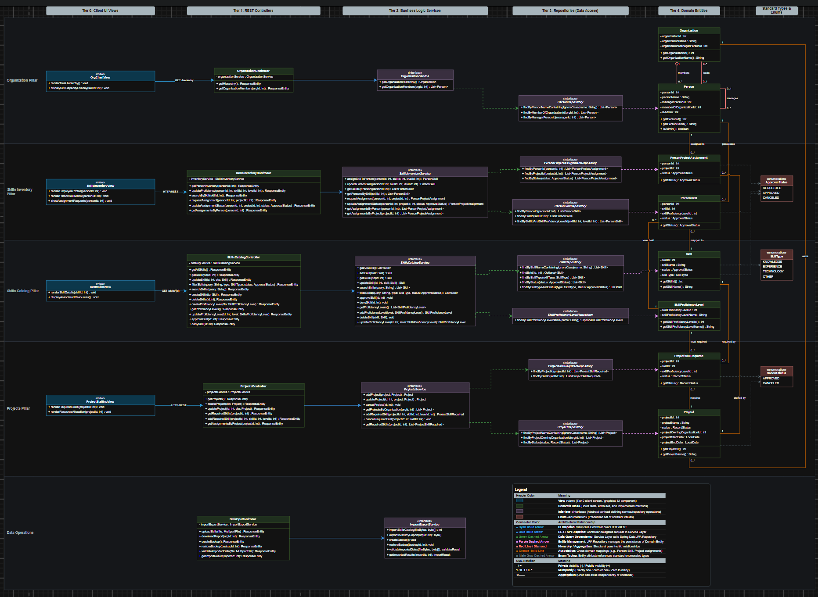

3.2 Tier Decomposition
- Tier 0: Client UI Views (Presentation Layer)
  - Provides the web-based graphical user interface views connecting users to the application.
  - Handles visual interaction, data rendering (including interactive organization trees and competency heatmaps), and dispatches HTTP/REST requests to backend controllers.
- Tier 1: REST Controllers (API Layer)
  - Provides HTTP/REST endpoints connecting the frontend views to backend business logic.
  - Dispatches transport DTOs (Data Transfer Objects) and handles response entity encapsulation for all user interactions.
- Tier 2: Business Logic Services (Service Layer)
  - Implements enterprise business logic, validation rules, transactional integrity, and data transformation routines.
  - Serves as an abstraction layer between presentation endpoints and database persistence.
- Tier 3: Repositories (Data Access Layer)
  - Uses Spring Data JPA interfaces extending JpaRepository to abstract SQL operations against the PostgreSQL database.
  - Defines standard and custom query methods for personnel, skill catalog definitions, project staffing demands, and inventory mappings.
- Tier 4: Domain Entities & Enums (Persistence Layer)
  - Comprises persistent JPA entity classes mapped to relational tables and enumerated types enforcing standardized domain values.
  - Organized into four domain pillars: Organization, Skills Inventory, Skills Catalog, and Projects, alongside Data Operations.

3.3 Detailed Class Specifications by Tier
Tier 0: Client UI Views
- OrgChartView [View]
  - Attributes:
    - - orgChartData : OrganizationHierarchyDTO
    - - capacityHeatmap : Map<int, double>
  - Operations:
    - + renderTreeHierarchy() : void
    - + displaySkillCapacityOverlay(skillId: int) : void
    - + onSelectOrganization(orgId: int) : void
- SkillsInventoryView [View]
  - Attributes:
    - - personSkills : List<PersonSkill>
  - Operations:
    - + renderEmployeeProfile(personId: int) : void
    - + renderPersonSkillMatrix(personId: int) : void
    - + showAssignmentRequests(personId: int) : void
- SkillDetailView [View]
  - Attributes:
    - - selectedSkill : Skill
    - - associatedResources : List<PersonSkill>
  - Operations:
    - + renderSkillDetails(skillId: int) : void
    - + displayAssociatedResources() : void
- ProjectStaffingView [View]
  - Attributes:
    - - projectDemands : List<ProjectSkillRequired>
  - Operations:
    - + renderRequiredSkills(projectId: int) : void
    - + renderResourceAllocation(projectId: int) : void
Tier 1: REST Controllers
- OrganizationController [Class]
  - Attributes:
    - - organizationService : OrganizationService
  - Operations:
    - + getHierarchy() : ResponseEntity
    - + getOrganizationMembers(orgId: int) : ResponseEntity
- SkillsInventoryController [Class]
  - Attributes:
    - - inventoryService : SkillsInventoryService
  - Operations:
    - + getPersonInventory(personId: int) : ResponseEntity
    - + updateProficiency(personId: int, skillId: int, levelId: int) : ResponseEntity
    - + searchBySkill(skillId: int) : ResponseEntity
    - + requestAssignment(personId: int, projectId: int) : ResponseEntity
    - + updateAssignmentStatus(personId: int, projectId: int, status: ApprovalStatus) : ResponseEntity
    - + getAssignmentsByPerson(personId: int) : ResponseEntity
- SkillsCatalogController [Class]
  - Attributes:
    - - catalogService : SkillsCatalogService
  - Operations:
    - + getAllSkills() : ResponseEntity
    - + getSkillById(id: int) : ResponseEntity
    - + updateSkill(id: int, dto: Skill) : ResponseEntity
    - + filterSkills(query: String, type: SkillType, status: ApprovalStatus) : ResponseEntity
    - + searchSkills(query: String) : ResponseEntity
    - + createSkill(dto: Skill) : ResponseEntity
    - + deleteSkills(id: int) : ResponseEntity
    - + createProficiencyLevel(dto: SkillProficiencyLevel) : ResponseEntity
    - + getProficiencyLevels() : ResponseEntity
    - + updateProficiencyLevel(id: int, level: SkillsProficiencyLevel) : ResponseEntity
    - + approveSkill(id: int) : ResponseEntity
    - + denySkill(id: int) : ResponseEntity

- ProjectsController [Class]
  - Attributes:
    - - projectsService : ProjectsService
  - Operations:
    - + getProjects() : ResponseEntity
    - + createProject(dto: Project) : ResponseEntity
    - + updateProject(id: int, dto: Project) : ResponseEntity
    - + getRequiredSkills(projectId: int) : ResponseEntity
    - + addRequiredSkill(projectId: int, skillId: int, levelId: int) : ResponseEntity
    - + getAssignmentsByProject(projectId: int) : ResponseEntity
- DataOpsController [Class]
  - Attributes:
    - - importExportService : ImportExportService
  - Operations:
    - + uploadSkills(file: MultipartFile) : ResponseEntity
    - + downloadReport(orgId: int) : ResponseEntity
    - + createBackup() : ResponseEntity
    - + restoreBackup(backupId: int) : ResponseEntity
    - + validateImportedData(file: MultipartFile) : ResponseEntity
    - + getImportResult(importId: int) : ResponseEntity
Tier 2: Business Logic Services
- OrganizationService [Interface]
  - Operations:
    - + getOrganizationHierarchy() : Organization
    - + getOrganizationMembers(orgId: int) : List<Person>
- SkillsInventoryService [Interface]
  - Operations:
    - + assignSkillToPerson(personId: int, skillId: int, levelId: int) : PersonSkill
    - + updatePersonSkill(personId: int, skillId: int, levelId: int) : PersonSkill
    - + getSkillsByPerson(personId: int) : List<PersonSkill>
    - + getPersonsBySkill(skillId: int) : List<PersonSkill>
    - + requestAssignment(personId: int, projectId: int) : PersonProjectAssignment
    - + updateAssignmentStatus(personId: int, projectId: int, status: ApprovalStatus) : PersonProjectAssignment
    - + getAssignmentsByPerson(personId: int) : List<PersonProjectAssignment>
    - + getAssignmentsByProject(projectId: int) : List<PersonProjectAssignment>

- SkillsCatalogService [Interface]
  - Operations:
    - + getAllSkills() : List<Skill>
    - + addSkill(skill: Skill) : Skill
    - + getSkillById(id: int) : Skill
    - + updateSkill(id: int, skill: Skill) : Skill
    - + searchSkills(query: String) : List<Skill>
    - + filterSkills(query: String, type: SkillType, status: ApprovalStatus) : List<Skill>
    - + approveSkill(id: int) : void
    - + denySkill(id: int) : void
    - + getProficiencyLevels() : List<SkillProficiencyLevel>
    - + addProficiencyLevel(level: SkillProficiencyLevel) : SkillProficiencyLevel
    - + deleteSkill(skill: Skill) : void
    - + updateProficiencyLevel(id: int, level: SkillsProficiencyLevel) : SkillProficiencyLevel
- ProjectsService [Interface]
  - Operations:
    - + addProject(project: Project) : Project
    - + updateProject(id: int, project: Project) : Project
    - + cancelProject(id: int) : void
    - + getProjectsByOrganization(orgId: int) : List<Project>
    - + addRequiredSkill(projectId: int, skillId: int, levelId: int) : ProjectSkillRequired
    - + cancelRequiredSkill(projectId: int, skillId: int) : void
    - + getRequiredSkills(projectId: int) : List<ProjectSkillRequired>
- ImportExportService [Interface]
  - Operations:
    - + importSkillsCatalog(fileBytes: byte[]) : int
    - + exportInventoryReport(orgId: int) : byte[]
    - + createBackup() : void
    - + restoreBackup(backupId: int) : void
    - + validateImportedDatra(fileBytes: byte[]) : validateResult
    - + getImportedResults(importId: int) : ImportResult
Tier 3: Repositories (Data Access)
- PersonRepository [Interface]
  - Operations:
    - + findByPersonNameContainingIgnoreCase(name: String) : List<Person>
    - + findByMemberOfOrganizationId(orgId: int) : List<Person>
    - + findByManagerPersonId(managerId: int) : List<Person>
- PersonProjectAssignmentRepository [Interface]
  - Operations:
    - + findByPersonId(personId: int) : List<PersonProjectAssignment>
    - + findByProjectId(projectId: int) : List<PersonProjectAssignment>
    - + findByStatus(status: ApprovalStatus) : List<PersonProjectAssignment>
- PersonSkillRepository [Interface]
  - Operations:
    - + findByPersonId(personId: int) : List<PersonSkill>
    - + findBySkillId(skillId: int) : List<PersonSkill>
    - + findBySkillIdAndSkillProficiencyLevelId(skillId: int, levelId: int) : List<PersonSkill>
- SkillRepository [Interface]
  - Operations:
    - + findBySkillNameContainingIgnoreCase(name: String) : List<Skill>
    - + findById(id: int) : Optional<Skill>
    - + findBySkillType(skillType: SkillType) : List<Skill>
    - + findByStatus(status: ApprovalStatus) : List<Skill>
    - + findBySkillTypeAndStatus(type: SkillType, status: ApprovalStatus) : List<Skill>
- SkillProficiencyLevelRepository [Interface]
  - Operations:
    - + findBySkillProficiencyLevelName(name: String) : Optional<SkillProficiencyLevel>
- ProjectSkillRequiredRepository [Interface]
  - Operations:
    - + findByProjectId(projectId: int) : List<ProjectSkillRequired>
    - + findBySkillId(skillId: int) : List<ProjectSkillRequired>
- ProjectRepository [Interface]
  - Operations:
    - + findByProjectNameContainingIgnoreCase(name: String) : List<Project>
    - + findByProjectOwningOrganizationId(orgId: int) : List<Project>
    - + findByStatus(status: RecordStatus) : List<Project>
Tier 4: Domain Entities & Enums
Organization Pillar
- Organization [Class]
  - - organizationId : int
  - - organizationName : String
  - - organizationManagerPersonId : int
  - + getOrganizationId() : int
  - + getOrganizationName() : String
- Person [Class]
  - - personId : int
  - - personName : String
  - - managerPersonId : int
  - - memberOfOrganizationId : int
  - - isAdmin : int
  - + getPersonId() : int
  - + getPersonName() : String
  - + isAdmin() : boolean
Skills Inventory Pillar
- PersonProjectAssignment [Class]
  - - personId : int
  - - projectId : int
  - - status : ApprovalStatus
  - + getStatus() : ApprovalStatus
- PersonSkill [Class]
  - - personId : int
  - - skillId : int
  - - skillProficiencyLevelId : int
  - - status : ApprovalStatus
  - + getStatus() : ApprovalStatus
Skills Catalog Pillar
- Skill [Class]
  - - skillId : int
  - - skillName : String
  - - status : ApprovalStatus
  - - skillType : SkillType
  - + getSkillId() : int
  - + getSkillName() : String

- SkillProficiencyLevel [Class]
  - - skillProficiencyLevelId : int
  - - skillProficiencyLevelName : String
  - + getSkillProficiencyLevelId() : int
  - + getSkillProficiencyLevelName() : String
Projects Pillar
- ProjectSkillRequired [Class]
  - - projectId : int
  - - skillId : int
  - - skillProficiencyLevelId : int
  - - status : RecordStatus
  - + getStatus() : RecordStatus
- Project [Class]
  - - projectId : int
  - - projectName : String
  - - status : RecordStatus
  - - projectOwningOrganizationId : int
  - - projectStartDate : LocalDate
  - - projectEndDate : LocalDate
  - + getProjectId() : int
  - + getProjectName() : String
Standard Types & Enums
- SkillType [Enum]: KNOWLEDGE, EXPERIENCE, TECHNOLOGY, OTHER
- RecordStatus [Enum]: APPROVED, CANCELED
- ApprovalStatus [Enum]: REQUESTED, APPROVED, CANCELED

4. Dynamic Model (SEQUENCE DIAGRAMS): Link to Dynamic Model

4.1 Figures 8–13: Dynamic Model
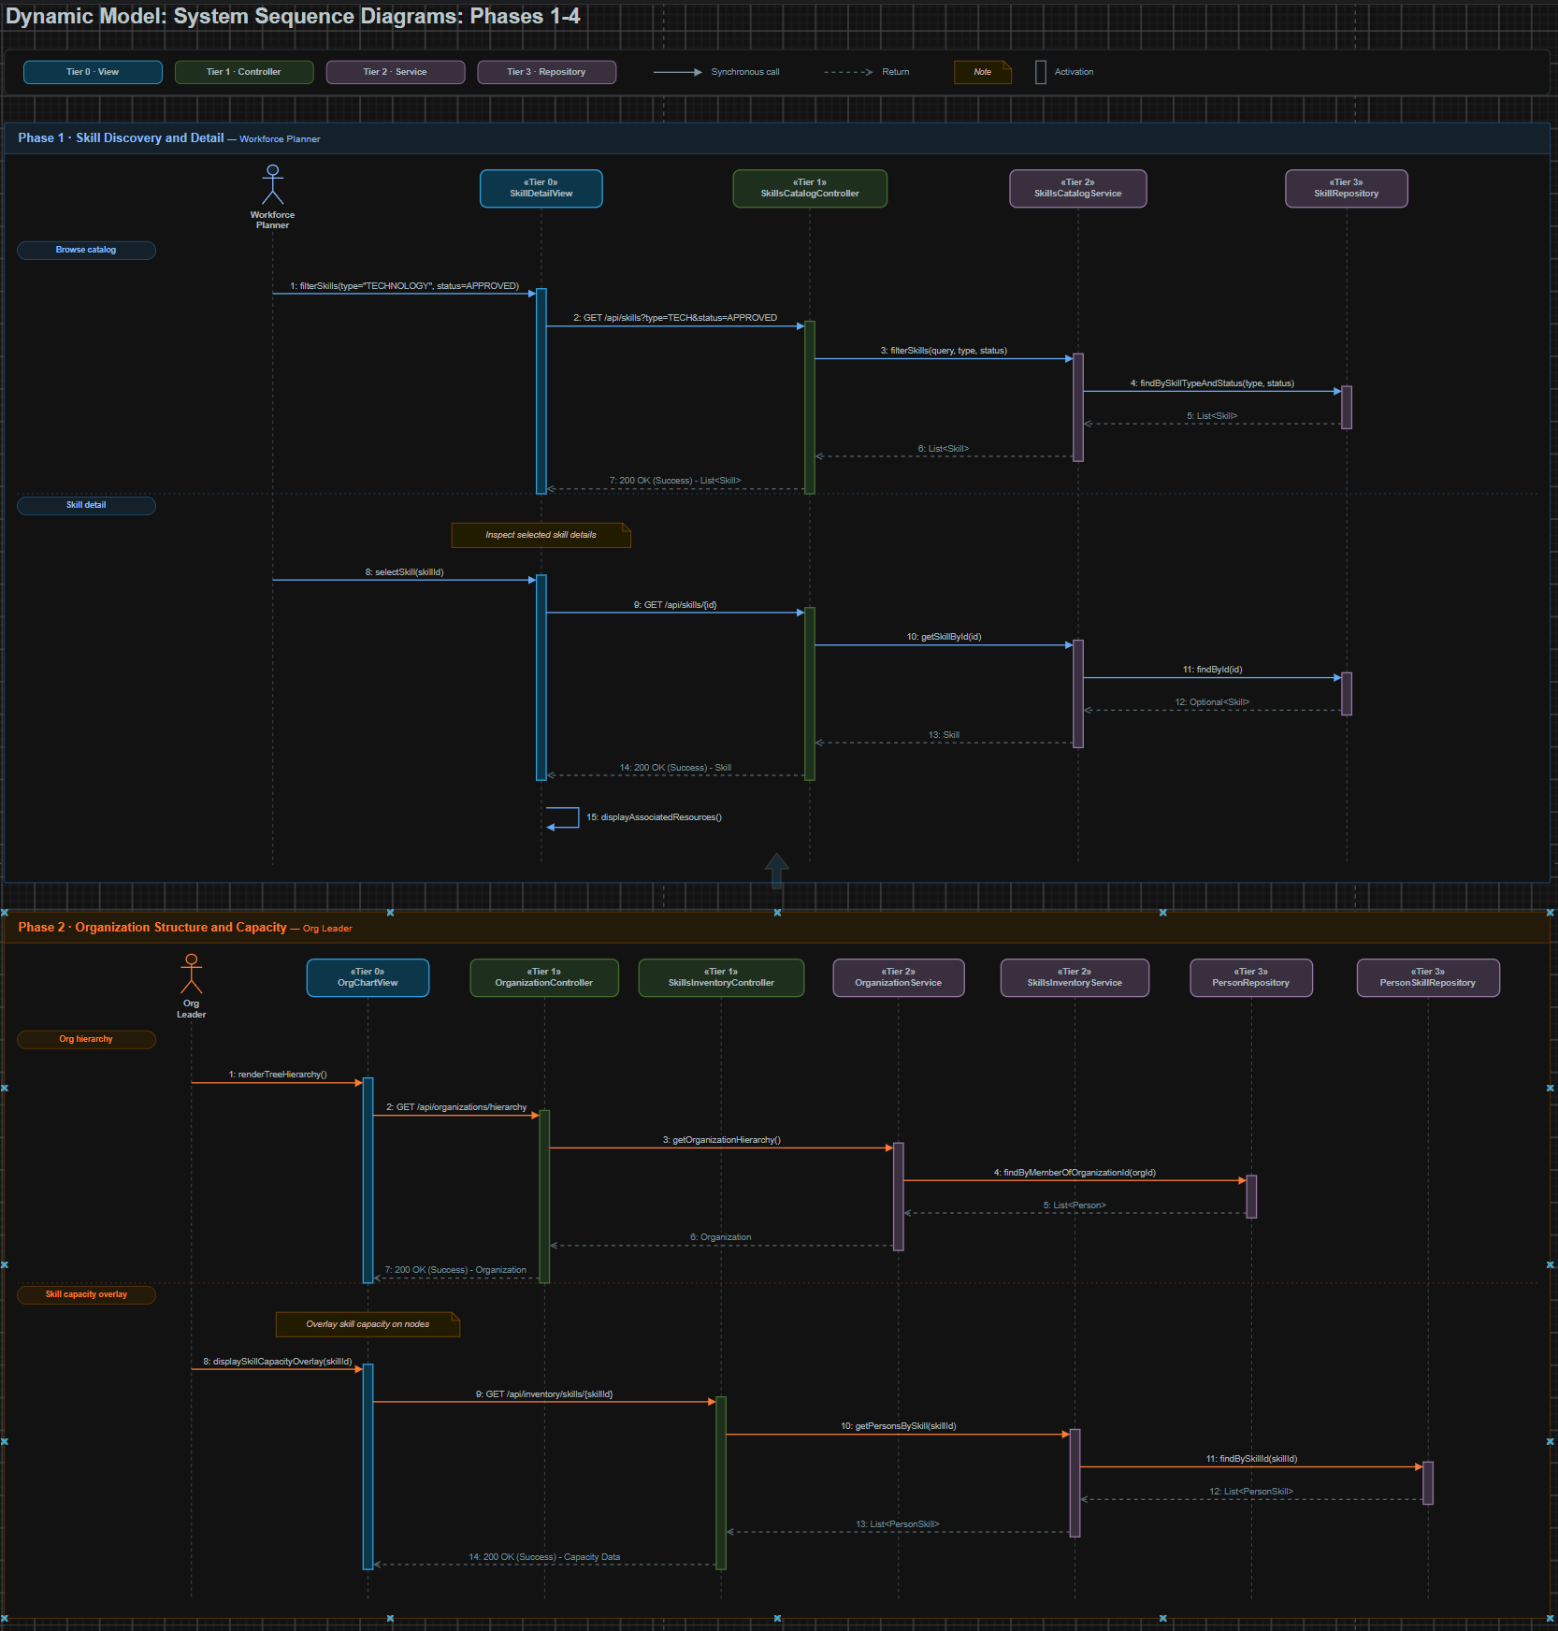

4.1 Figure 9: Dynamic Model (Phases 3 - 4)
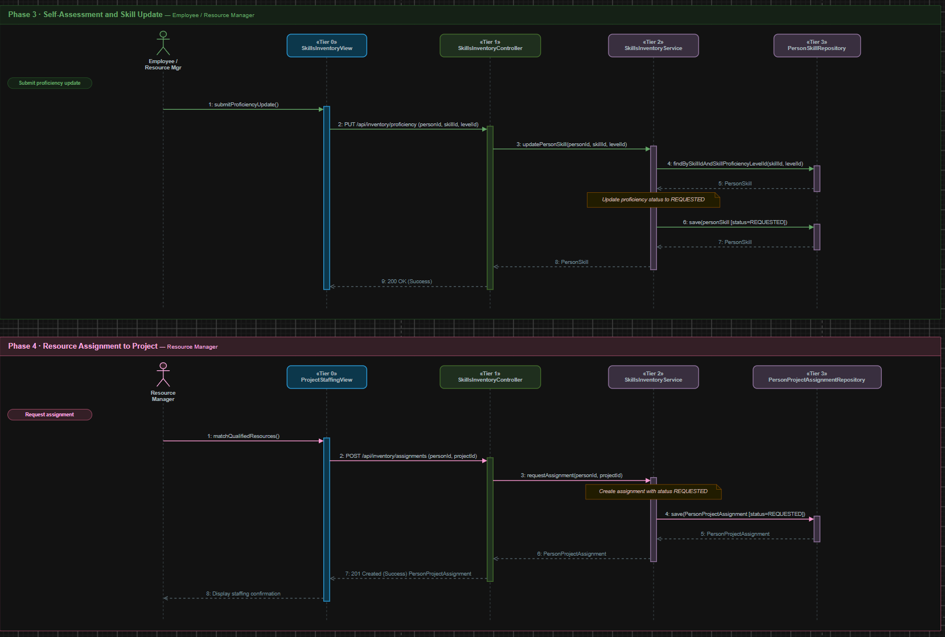

4.1 Figure 10: Dynamic Model (Phase 5)
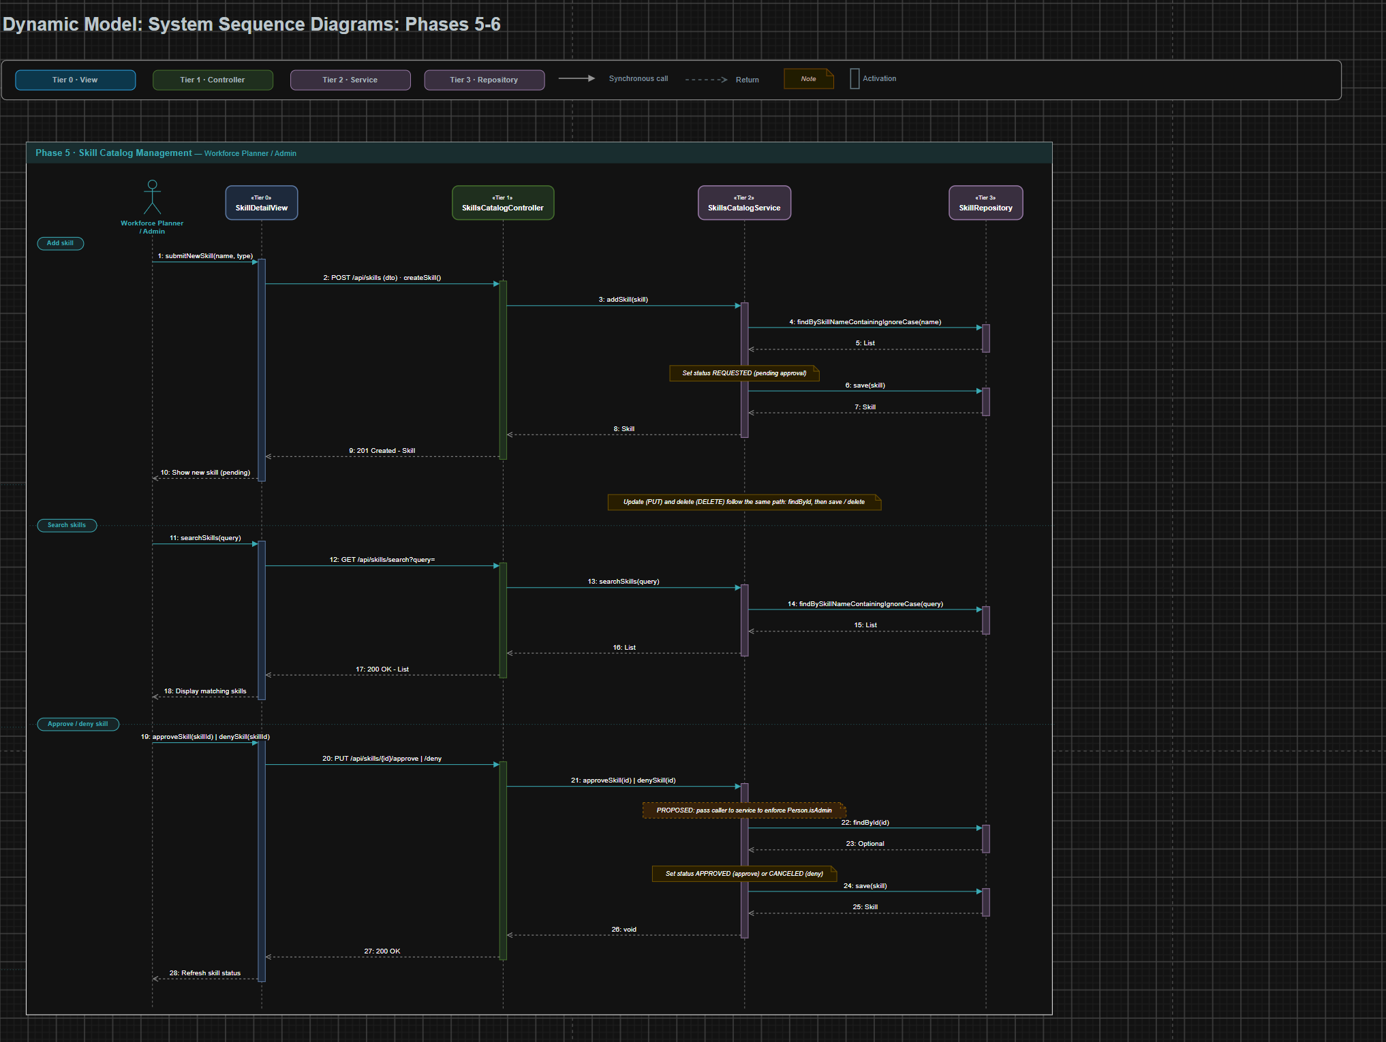

4.1 Figure 11: Dynamic Model (Phase 6)
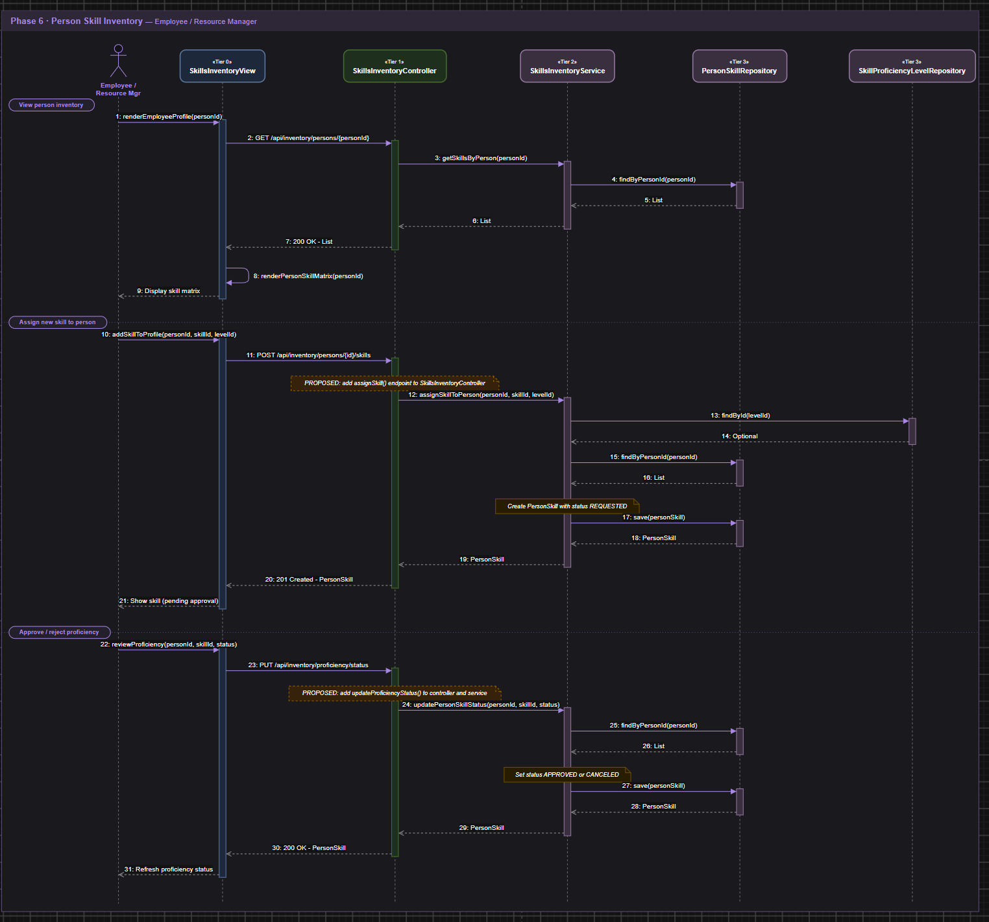

4.1 Figure 12: Dynamic Model (Phase 7)
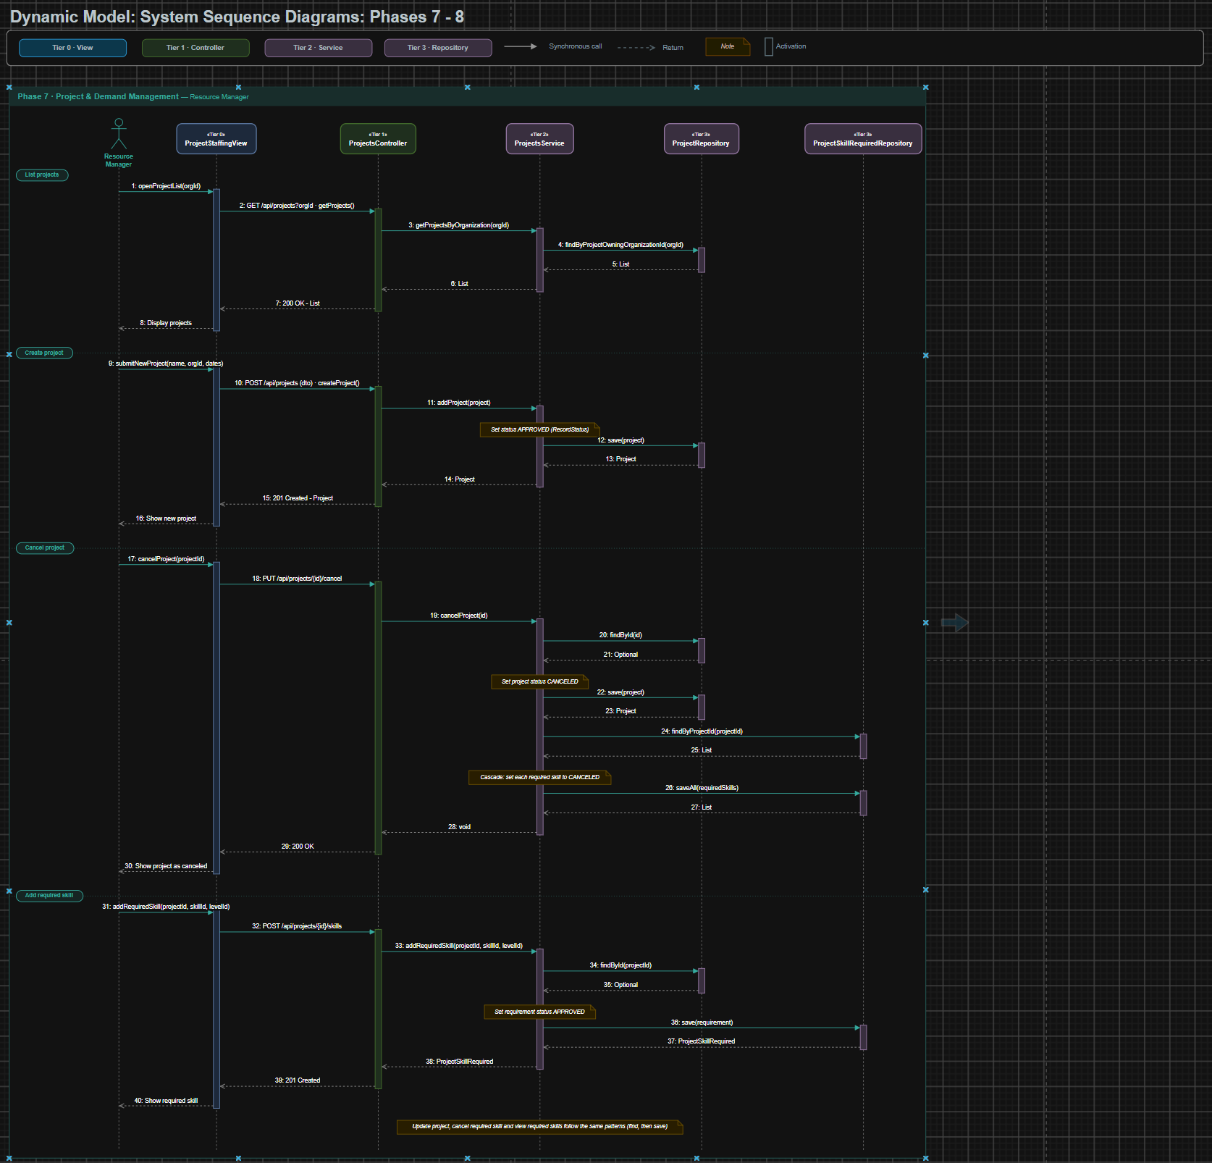

4.1 Figure 13: Dynamic Model (Phase 8)
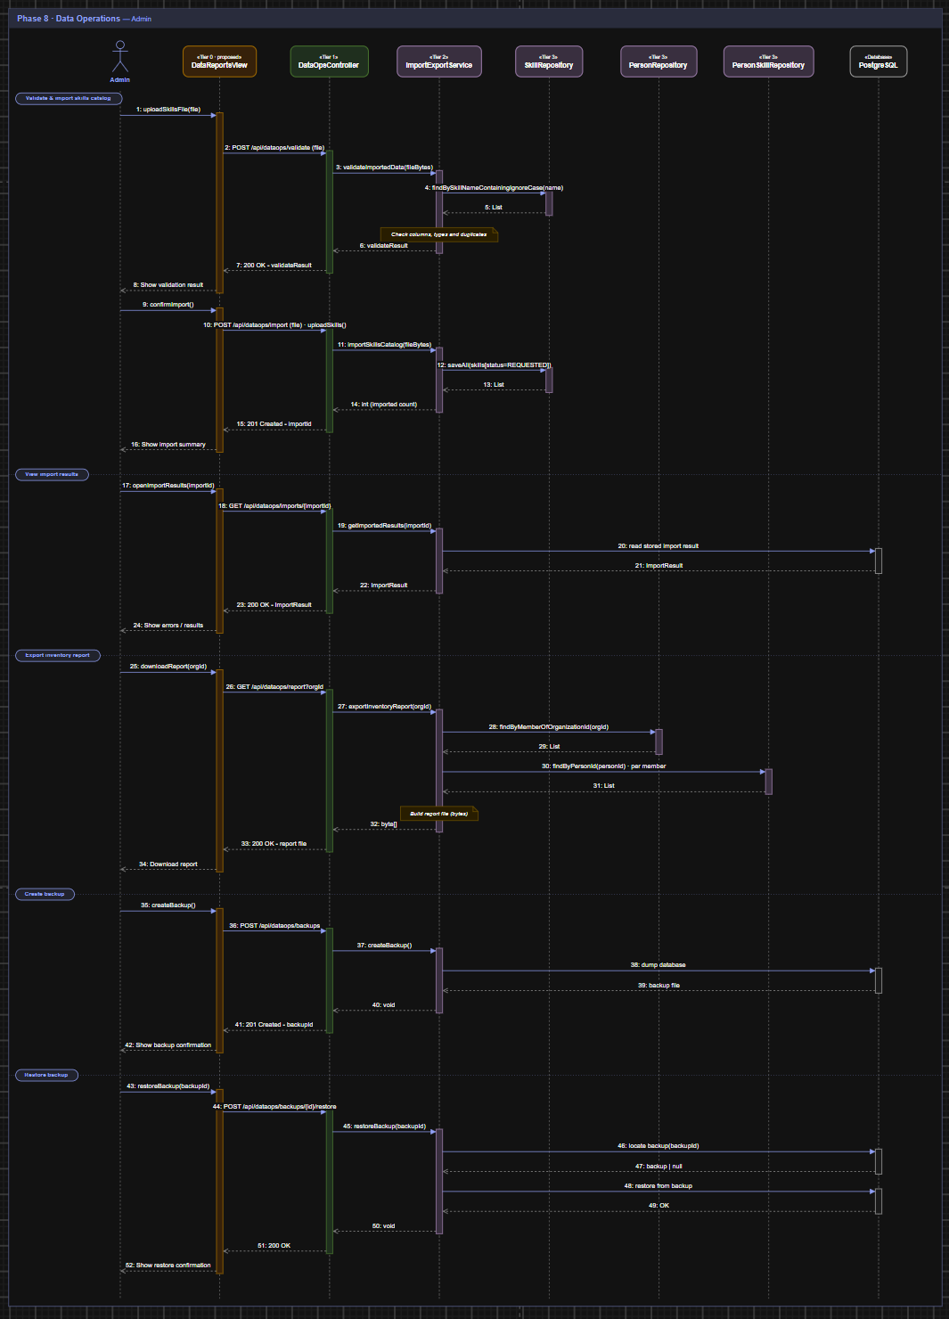

4.2 Dynamic Model Overview & Notation
The Dynamic Model illustrates the runtime behavioral interactions across the 5 architectural tiers defined in the static model:
- Tier 0 · Client View Layer: Frontend view components (e.g., SkillDetailView, OrgChartView, SkillsInventoryView, ProjectStaffingView, DataReportsView) that capture user events and render graphical/data representations.
- Tier 1 · REST Controller Layer: Spring REST controllers dispatching incoming HTTP requests (GET, POST, PUT, DELETE) and wrapping responses in ResponseEntity.
- Tier 2 · Business Logic Services: Service interfaces executing core business rules, validations, entity conversions, and orchestration.
- Tier 3 · Data Access Repositories: Spring Data JPA repository interfaces executing query methods against the persistence storage.
- Tier 4 · Domain Entities / PostgreSQL Database: The underlying relational storage and domain entity states managing persistent lifecycle records.

UML Notation Conventions:
- Solid arrows with filled arrowheads (—>): Synchronous message calls and REST API requests.
- Dashed arrows with open arrowheads (-->): Return messages returning transfer DTOs, entity instances, or HTTP response entities.
- Vertical activation bars: Active processing execution periods on participant lifelines.
- Notes & Frames: Boundary groupings representing transactional units of work, status transitions, and cascade policies.

4.3 Detailed Phase Decompositions
Phase 1: Skill Discovery and Detail (Workforce Planner)
- Participants: Workforce Planner [Actor], SkillDetailView [Tier 0], SkillsCatalogController [Tier 1], SkillsCatalogService [Tier 2], SkillRepository [Tier 3].
- Workflow & Execution Steps:
  - Browse Catalog: The Workforce Planner submits catalog search filters (type="TECHNOLOGY", status=APPROVED) in SkillDetailView.
  - REST Dispatch: SkillDetailView issues GET /api/skills?type=TECH&status=APPROVED to SkillsCatalogController.filterSkills().
  - Business Service Call: SkillsCatalogController delegates to SkillsCatalogService.filterSkills(query, type, status).
  - Repository Query: SkillsCatalogService executes SkillRepository.findBySkillTypeAndStatus(type, status).
  - Return Chain: SkillRepository returns List<Skill> back through the service and controller to SkillDetailView as 200 OK.
  - Skill Detail Inspection: The user selects a specific skill (skillId). SkillDetailView dispatches GET /api/skills/{id} to SkillsCatalogController.getSkillById(id).
  - Persistence Lookup: SkillsCatalogService.getSkillById(id) queries SkillRepository.findById(id) returning Optional<Skill>.
  - Resource View Display: SkillsCatalogController returns 200 OK (Skill). SkillDetailView executes self-call displayAssociatedResources() to render qualified personnel and project demand associations.

Phase 2: Organization Structure and Capacity (Organizational Leader)
- Participants: Org Leader [Actor], OrgChartView [Tier 0], OrganizationController [Tier 1], SkillsInventoryController [Tier 1], OrganizationService [Tier 2], SkillsInventoryService [Tier 2], PersonRepository [Tier 3], PersonSkillRepository [Tier 3].
- Workflow & Execution Steps:
  - Render Org Hierarchy: The Organizational Leader invokes renderTreeHierarchy() on OrgChartView.
  - Hierarchy REST Call: OrgChartView issues GET /api/organizations/hierarchy to OrganizationController.getHierarchy().
  - Service Delegation: OrganizationService.getOrganizationHierarchy() calls PersonRepository.findByMemberOfOrganizationId(orgId) to retrieve members.
  - Hierarchy Return: The assembled Organization hierarchy graph returns through OrganizationController as 200 OK to OrgChartView.
  - Skill Capacity Overlay: The user triggers displaySkillCapacityOverlay(skillId) to project competency density across units.
  - Inventory REST Call: OrgChartView issues GET /api/inventory/skills/{skillId} to SkillsInventoryController.searchBySkill(skillId).
  - Skill Association Query: SkillsInventoryService.getPersonsBySkill(skillId) queries PersonSkillRepository.findBySkillId(skillId) returning List<PersonSkill>.
  - Overlay Render: SkillsInventoryController returns 200 OK (Capacity Data) to OrgChartView which renders capacity heatmap overlays across organizational nodes.

Phase 3: Self-Assessment and Skill Update (Employee / Resource Manager)
- Participants: Employee / Resource Mgr [Actor], SkillsInventoryView [Tier 0], SkillsInventoryController [Tier 1], SkillsInventoryService [Tier 2], PersonSkillRepository [Tier 3].
- Workflow & Execution Steps:
  - Proficiency Submission: The user updates an evaluated skill level via SkillsInventoryView.submitProficiencyUpdate().
  - REST Dispatch: SkillsInventoryView sends PUT /api/inventory/proficiency (personId, skillId, levelId) to SkillsInventoryController.updateProficiency().
  - Service Logic: SkillsInventoryController calls SkillsInventoryService.updatePersonSkill(personId, skillId, levelId).
  - Record Lookup: SkillsInventoryService queries PersonSkillRepository.findBySkillIdAndSkillProficiencyLevelId(skillId, levelId) to retrieve the association entity.
  - Status Transition: The service sets entity status to ApprovalStatus.REQUESTED (pending validation).
  - Persistence: SkillsInventoryService calls PersonSkillRepository.save(personSkill [status=REQUESTED]).
  - Response: PersonSkillRepository returns the updated entity through service and controller to SkillsInventoryView as 200 OK.

Phase 4: Resource Assignment to Project (Resource Manager)
- Participants: Resource Manager [Actor], ProjectStaffingView [Tier 0], SkillsInventoryController [Tier 1], SkillsInventoryService [Tier 2], PersonProjectAssignmentRepository [Tier 3].
- Workflow & Execution Steps:
  - Resource Match: The Resource Manager reviews matched personnel on ProjectStaffingView and clicks matchQualifiedResources().
  - REST Dispatch: ProjectStaffingView sends POST /api/inventory/assignments (personId, projectId) to SkillsInventoryController.requestAssignment().
  - Service Invocation: SkillsInventoryService.requestAssignment(personId, projectId) instantiates a PersonProjectAssignment with status ApprovalStatus.REQUESTED.
  - Persistence: SkillsInventoryService delegates to PersonProjectAssignmentRepository.save(PersonProjectAssignment [status=REQUESTED]).
  - Confirmation Return: PersonProjectAssignmentRepository confirms persistence; SkillsInventoryController responds with 201 Created (PersonProjectAssignment).
  - UI Notification: ProjectStaffingView displays staffing confirmation to the Resource Manager.

Phase 5: Skill Catalog Management (Workforce Planner / Admin)
- Participants: Workforce Planner / Admin [Actor], SkillDetailView [Tier 0], SkillsCatalogController [Tier 1], SkillsCatalogService [Tier 2], SkillRepository [Tier 3].
- Workflow & Execution Steps:
  - Add New Skill: The user submits new skill information (name, type) through SkillDetailView.
  - Creation Call: POST /api/skills (dto) is sent to SkillsCatalogController.createSkill(), delegating to SkillsCatalogService.addSkill(skill).
  - Uniqueness Verification: The service queries SkillRepository.findBySkillNameContainingIgnoreCase(name) to prevent duplicates.
  - Pending Status Assignment: The new Skill entity status is initialized to ApprovalStatus.REQUESTED and saved via SkillRepository.save(skill).
  - Search Skills: User invokes searchSkills(query). SkillsCatalogController.searchSkills(query) queries SkillRepository.findBySkillNameContainingIgnoreCase(query).
  - Approve / Deny Skill: Admin selects a skill to review, sending PUT /api/skills/{id}/approve or PUT /api/skills/{id}/deny to SkillsCatalogController.
  - Approval State Update: SkillsCatalogService.approveSkill(id) or denySkill(id) loads the skill via SkillRepository.findById(id), sets status to APPROVED or CANCELED, and commits via SkillRepository.save(skill).

Phase 6: Person Skill Inventory (Employee / Resource Manager)
- Participants: Employee / Resource Mgr [Actor], SkillsInventoryView [Tier 0], SkillsInventoryController [Tier 1], SkillsInventoryService [Tier 2], PersonSkillRepository [Tier 3], SkillProficiencyLevelRepository [Tier 3].
- Workflow & Execution Steps:
  - View Inventory Profile: User invokes renderEmployeeProfile(personId). SkillsInventoryView sends GET /api/inventory/persons/{personId} to SkillsInventoryController.getPersonInventory().
  - Fetch Associations: SkillsInventoryService.getSkillsByPerson(personId) calls PersonSkillRepository.findByPersonId(personId), returning List<PersonSkill> to render the skill matrix.
  - Assign New Skill to Profile: User adds an evaluated skill to an employee profile via SkillsInventoryView.
  - Proficiency Validation: SkillsInventoryService validates the selected level via SkillProficiencyLevelRepository.findById(levelId), checks existing mappings, initializes PersonSkill with ApprovalStatus.REQUESTED, and saves to PersonSkillRepository.
  - Review Proficiency: Resource Manager reviews pending skills, submitting PUT /api/inventory/proficiency/status. SkillsInventoryService updates status to APPROVED or CANCELED and commits to PersonSkillRepository.

Phase 7: Project & Demand Management (Resource Manager)
- Participants: Resource Manager [Actor], ProjectStaffingView [Tier 0], ProjectsController [Tier 1], ProjectsService [Tier 2], ProjectRepository [Tier 3], ProjectSkillRequiredRepository [Tier 3].
- Workflow & Execution Steps:
  - List Projects: ProjectStaffingView dispatches GET /api/projects?orgId to ProjectsController.getProjects().
  - Organization Project Query: ProjectsService.getProjectsByOrganization(orgId) queries ProjectRepository.findByProjectOwningOrganizationId(orgId) returning List<Project>.
  - Create Project: Resource Manager creates a project (name, orgId, dates) via POST /api/projects. ProjectsService.addProject() sets RecordStatus.APPROVED and persists via ProjectRepository.save(project).
  - Cancel Project: User invokes cancelProject(projectId) via PUT /api/projects/{id}/cancel.
  - Cascade Cancellation: ProjectsService.cancelProject(id) loads the project, sets status to RecordStatus.CANCELED, saves it, and then queries ProjectSkillRequiredRepository.findByProjectId(projectId) to cascade cancellation across all linked requirements using saveAll(requiredSkills).
  - Add Required Skill: Resource Manager defines staffing demand via POST /api/projects/{id}/skills. ProjectsService.addRequiredSkill(projectId, skillId, levelId) verifies project existence via ProjectRepository.findById(projectId) and persists ProjectSkillRequired with RecordStatus.APPROVED.

Phase 8: Data Operations (Admin)
- Participants: Admin [Actor], DataReportsView [Tier 0], DataOpsController [Tier 1], ImportExportService [Tier 2], SkillRepository [Tier 3], PersonRepository [Tier 3], PersonSkillRepository [Tier 3], PostgreSQL [Database].
- Workflow & Execution Steps:
  - Upload & Validate Catalog File: Admin selects a catalog dataset. DataReportsView dispatches POST /api/dataops/validate (file) to DataOpsController.validateImportedData().
  - Pre-Import Validation: ImportExportService.validateImportedData(fileBytes) parses headers, data types, and checks SkillRepository.findBySkillNameContainingIgnoreCase() to verify duplicate thresholds, returning a validateResult.
  - Confirm Import: Admin confirms import via POST /api/dataops/import (file). ImportExportService.importSkillsCatalog(fileBytes) bulk persists records with status REQUESTED via SkillRepository.saveAll() and returns the imported record count.
  - View Import Results: Admin requests historical logs via GET /api/dataops/imports/{importId}. ImportExportService.getImportedResults(importId) fetches stored execution reports from persistence.
  - Export Inventory Report: Admin requests organizational reporting via GET /api/dataops/report?orgId. ImportExportService.exportInventoryReport(orgId) queries PersonRepository.findByMemberOfOrganizationId(orgId) and retrieves associated skills via PersonSkillRepository.findByPersonId(), compiling and streaming a structured binary byte array (byte[]).
  - Database Backup: Admin dispatches POST /api/dataops/backups. ImportExportService.createBackup() executes a system database snapshot against PostgreSQL, storing the backup archive and returning a backupId.
  - Database Restore: Admin executes disaster recovery via POST /api/dataops/backups/{id}/restore. ImportExportService.restoreBackup(backupId) validates archive integrity, restores schema tables in PostgreSQL, and returns completion status.

5. RATIONALE FOR DESIGN MODEL
The rationale behind our detailed design model was to provide a clear representation of the Skills Inventory system’s architecture, components, and interactions. It translates the system requirements into a structured design by defining the responsibilities of individual classes and how they work together to support the system’s functionality. The separation of controllers, services, repositories, and entities promotes modularity by ensuring that each component has a set task to complete. Controllers manage incoming requests and coordinate operations, services handle business logic, repositories manage data access, and entities represent the system’s core information and relationships.
The design also establishes relationships between key entities such as Person, Skill, SkillCategory, and PersonSkill, allowing the system to organize skill information and associate skills with individuals. This structure supports operations such as creating and maintaining skills, searching for people based on their skills, managing person-skill associations, and retrieving organizational information. By defining these relationships and assigning responsibilities to specific components, the model provides a consistent approach to handling data and processing user requests.
Additionally, the detailed design promotes maintainability, reusability, and extensibility. Separating the system into distinct components makes it easier to modify or expand individual areas without unnecessarily affecting the rest of the application. For example, changes to skill-management operations can be handled within the relevant services and repositories while maintaining the overall structure of the system. The design also provides a foundation for understanding how the system’s components collaborate to fulfill user requirements and how the application can be implemented, tested, and maintained. Overall, the detailed design model establishes a logical and organized structure for the Skills Inventory system, connecting its data, business logic, and user-facing operations into a cohesive application.

6. TRACEABILITY FROM REQUIREMENTS TO DETAILED DESIGN MODEL

General / Business Operations Functional Requirements | Traces to Detailed Design Model
Import Skills Catalog | DataOpsController.uploadSkills(file) calls ImportExportService.importSkillsCatalog(fileBytes) to import the Skills Catalog data.
Load additional skills | SkillsCatalogController.createSkill(dto) calls SkillsCatalogService.addSkills(skill) to load additional skills.
Validate Imported Data | DataOpsController.validateImportedData(file) calls ImportExportService.validateImportedData(fileByte) to validate imported data and return the validation result
View Import Errors/Results | DataOpsController.getImportResult(importId) calls ImportExportService.getImportResults(importId) to get import results from previous imports.
Export Data | DataOpsController.downloadReport(orgId) calls ImportExportService.exportInventoryReport(orgId) to export the data.
Backup | DataOpsController.createBackup() calls ImportExportService.createBackup() to create a system data backup
Restoration | DataOpsController.restoreBackup(backupId) calls ImportExportService.restoreBackup(backupId) to restore system data from a selected backup.
Approve or deny additional skills | SkillsCatalogService.approveSkill(id) helps approve the skill, and SkillsCatalogService.denySkill(id) helps deny the skill.
Web-based system | REST Controllers, including OrganizationController, SkillsCatalogController, SkillsInventoryController, ProjectsController, and DataOpsController, provide endpoints for communication with the web-based front-end.
Cancel | ProjectsService.cancelProject(id) method helps cancel the Project, and the ProjectsService.cancelRequiredSkills(projectId, skillId) method helps cancel the required skill.

Workforce Planner Functional Requirements | Traces to Detailed Design Model
Views Skills Catalog | SkillsCatalogController.getAllSkills() calls SkillsCatalogService.getAllSkills() to retrieve all skills from the Skills Catalog
Add Skills | SkillsCatalogController.createSkill(dto) receives new skill information, and SkillsCatalogService.addSkills(skill) helps add new skills to the catalog
Update Skills | SkillsCatalogController.updateSkill(id, dto) receives updated skill information, and SkillsCatalogService.updateSkills(id, skill) updates the existing skill
Search Skills | SkillsCatalogController.searchSkills(query) calls SkillsCatalogService.searchSkills(query) to search a skill
View Skills Details | SkillsCatalogController.getSkillById(id) calls SkillsCatalogService.getSkillById(id) to retrieve details of the selected skill.
Maintain Skill Type | SkillsCatalogController.createSkill(dto) and updateSkill(id, dto) call SkillsCatalogService.addSkill(skill) and updateSkill(id, skill) to assign or modify the skill type associated with a skill.
Maintaining Skill Proficiency Levels | SkillsCatalogController. createProficiencyLevel (dto), getProficiencyLevels(), and updateProficiencyLevel(id, level) call the corresponding methods in SkillsCatalogService to create, view, and update skill proficiency levels.
Graphical UI | React frontend provides a graphical user interface that allows Workforce Planners to interact with the Skills Catalog through the SkillsCatalogController

Resource Manager Functional Requirements | Traces to Detailed Design Model
Creating/Maintaining Skills Inventory | SkillsCatalogController.getAllSkills(), SkillsCatalogController.createSkill(), SkillsCatalogController.updateSkill(), and SkillsCatalogController.deleteSkills() call SkillsCatalogService.getAllSkills(), SkillsCatalogService.addSkill(), SkillsCatalogService.updateSkill(), and SkillsCatalogService.deleteSkill() to retrieve, create, update, and delete skills in the catalog. SkillsInventoryController.getPersonInventory() and SkillsInventoryController.updateProficiency() call SkillsInventoryService.getSkillsByPerson(), SkillsInventoryService.assignSkillToPerson(), and SkillsInventoryService.updatePersonSkill() to manage skills associated with a person. SkillRepository and PersonSkillRepository support persistence and retrieval.
Search for a specific resource or organization to view their skills | SkillsInventoryController.getPersonInventory(personId) calls SkillsInventoryService.getSkillsByPerson(personId) to retrieve a person's skills. PersonRepository.findByPersonNameContainingIgnoreCase(name) supports searching for a person by name, while PersonRepository.findByMemberOfOrganizationId(orgId) retrieves people belonging to an organization. OrganizationController.getOrganizationMembers(orgId) calls OrganizationService.getOrganizationMembers(orgId) to retrieve organizational members. Note: There is no explicit method to retrieve all skills associated with an organization or to search for a person by name and directly return their skills in one operation.
Search for a specific skill and see all associated resources | SkillsInventoryController.searchBySkill(skillId) calls SkillsInventoryService.getPersonsBySkill(skillId) to retrieve people associated with a specific skill. PersonSkillRepository.findBySkillId(skillId) retrieves the person-skill associations for that skill.
View UI | Tier 0 Client Views (OrgChartView, SkillsInventoryView, SkillDetailView, ProjectStaffingView) handle UI presentation and dispatch HTTP/REST requests to Tier 1 REST Controllers (OrganizationController, SkillsInventoryController, SkillsCatalogController, ProjectsController) to view and manage inventory, staffing, and catalog data.
Create, view, and maintain association between skill and resource | SkillsInventoryService.assignSkillToPerson(personId, skillId, levelId) creates the association between a person and a skill, while SkillsInventoryService.updatePersonSkill(personId, skillId, levelId) updates the person's skill proficiency. SkillsInventoryService.getSkillsByPerson(personId) retrieves the person's skills. PersonSkillRepository.findByPersonId(personId) and PersonSkillRepository.findBySkillId(skillId) support retrieving these associations
View specific Skill UI | SkillDetailView renders dedicated skill metadata and invokes SkillsCatalogController.getSkillById() which delegates to SkillsCatalogService.getSkillById() and SkillRepository.findById(), while displayAssociatedResources() presents qualified personnel and active project resource requirements
Skill Validation | SkillController.getApprovedSkills() calls SkillService.getApprovedSkills(), while Skill has a SkillStatus field and an isApproved() method. PersonSkillController.approveSkill(personId, skillId) calls PersonSkillService.approveSkill() to approve a person's skill association.
Certification Tracking | SkillsInventoryService.addCertification(empId, cert) calls SkillsInventoryService to add Certification

Organizational Leader Functional Requirements | Traces to Detailed Design Model
View summary | OrganizationController.getHierarchy() calls OrganizationService.getOrganizationHierarchy() to retrieve the organizational chart. OrganizationController.getOrganizationMembers(orgId) calls OrganizationService.getOrganizationMembers(orgId) to retrieve organization members.
Filter Skills | SkillsCatalogController.filterSkills(query, type, status) delegates to SkillsCatalogService.filterSkills() and SkillRepository.findBySkillTypeAndStatus() / findByStatus(), supporting multi-criteria filtering against ApprovalStatus (REQUESTED, APPROVED, CANCELED) and SkillType
View distribution | PersonSkillService.findPeopleBySkill(skillId, minLevelId) and PersonSkillRepository.findByIdSkillIdAndProficiencyLevelId(skillId, levelId) provide data about people with specific skills and proficiency levels. OrganizationService.getOrganizationMembers(orgId) and PersonService.getPeopleByOrganization(orgId) provide organizational membership data.
Graphical views | OrgChartView renders the visual hierarchy tree through OrganizationController.getHierarchy() calling OrganizationService.getOrganizationHierarchy(), while OrgChartView.displaySkillCapacityOverlay() presents interactive competency heatmap overlays.
Skill capacity | PersonSkillService.findPeopleBySkill(skillId, minLevelId) and PersonSkillRepository.findByIdSkillIdAndLevelId(skillId, levelId) can identify people with particular skills and proficiency levels. ProjectSkillRequiredService.getRequiredSkills(projectId) and ProjectSkillRequiredRepository.findByIdProjectId(projectId) provide project skill requirements.
Skill Trend & Historical Analytics | PersonSkill.updateProficiency() and PersonSkillService.updateProficiency() support updating proficiency, while PersonSkill.status records the current association status.
Organization Hierarchy | OrganizationService.getOrganizationHierarchy() and OrganizationService.getDepartmentDistribution(deptId) calls OrganizationService to provide hierarchy and distribution while OrganizationController.getDepartmentDistribution(deptId) calls for the OrganizationController and OrganizationRepository.findByTeamId(teamId) support retrieving organization structure and department distribution.

7. Configuration Management
- Github Repository: https://github.com/kimchau123/SE-4385-Group-9
Name | Version Before | Version After | Difference between 2 consecutive versions | Review | Comments
Tobenna | 0.00 | 0.01 | Document Created | Shipped | Start of Detailed Design Documentation
Tobenna | 0.01 | 0.02 | Template Added to Document | Shipped
Jasmine | 0.02 | 0.03 | Abstract | Shipped
Kim | 0.03 | 0.04 | Introduction to the entire document | Shipped
Jason | 0.04 | 0.05 | Purpose and Scope | Shipped
Jasmine | 0.05 | 0.06 | Description of the structure of the document | Shipped
Kim | 0.06 | 0.07 | Traceability from requirements to detailed design model for General/Business Operations and Workforce Planner. | Shipped
Team | 0.07 | 0.08 | Static Model | Shipped
Team | 0.08 | 0.09 | Dynamic Model | Shipped
Russel / Alice / Tobenna / Kim | 0.09 | 0.10 | GUI Design | Shipped
Alice | 0.10 | 0.11 | Traceability from requirements to detailed design model for Resource Manager and Organization Leader. | Shipped
Alice | 0.11 | 0.12 | Rationale for Detailed Design Model | Shipped
Team | 0.12 | 0.13 | Document Completed | Shipped | End of Detailed Design Documentation
8. Engineering Standards and Multiple Constraints

- IEEE Std 1016-1998-(Revision-2009): Software Design [pdf]

9. Glossary
- Tier Decomposition: An architectural pattern that divides the system into distinct logical layers or tiers (e.g., Client UI Views, REST Controllers, Business Logic Services, Repositories, and Domain Entities) to promote separation of concerns and modularity.
- REST Controllers: The API layer component (Tier 1) responsible for receiving HTTP requests from the front-end client, invoking the corresponding business services, and returning response data encapsulated in DTOs.
- DTO (Data Transfer Object): An object used to carry data between software subsystem layers, specifically between backend controllers and front-end client UI views.
- Domain Entities: Persistent object classes (Tier 4) mapped to relational database tables representing the core business concepts, data structures, and relationships of the application.
- Skills Catalog: The centralized repository of master skill definitions, skill types, categories, and proficiency levels maintained and used across the organization.
- Skills Inventory: The mapping system that associates specific employees with defined skills from the catalog, including their evaluated proficiency levels, approval statuses, and certifications.
- Repositories: The data access layer components (Tier 3) that abstract database interaction using Spring Data JPA interfaces to query and manipulate domain entities in PostgreSQL.
10. Additional References

- Larman, C., 2012. Applying UML and Patterns: An Introduction to Object Oriented Analysis and Design and Iterative Development. Pearson Education
- Hyman, B., 1998. Fundamentals of Engineering Design. New Jersey: Prentice Hall
- Simon, H.A., 2014. A Student's Introduction to Engineering Design: Pergamon Unified Engineering Series (Vol. 21). Elsevier

.

